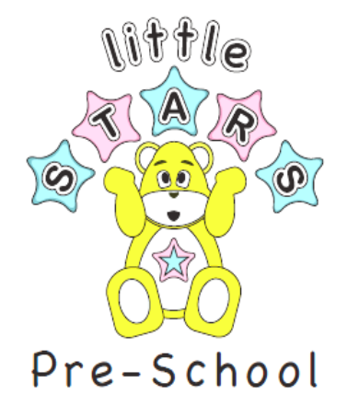
15th October 2021

Dear families,

The week commencing 18th- 22nd October

We are inviting all children to attend Pre-School in their favorite dressing up costume!

The children can take part in the spooky fun and pumpkin patch, an apple bobbing and lots of arts and crafts and cake making.

Thank you

Little Stars Team

