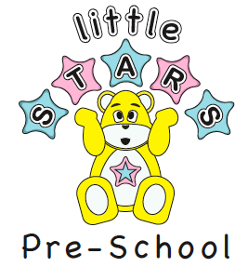

Little Stars Pre School Ltd
At The Mill Primary School
Ifield Drive, Crawley
West Sussex RH11 0EL ©
Telephone: 07975752798
01293-510713
e-mail office@littlestars-preschool.co.uk

15th October 2021
Dear Little stars Families,
Next Terms dates
12th November 9am until 10am
26th November 9am until 10am
10th December 9am until 10am
All welcome 💫 Please book a place as limited availability.
Minimum Contribution £1.50 per child all proceeds will go to serve Surrey and London💫 an excellent charity supporting Surrey & London they are a charity organisation, made up entirely of volunteers. They transport blood products, urgent samples, medical supplies along with donated breast milk to hospitals and milk banks across Surrey & London. They also ensure that Air Ambulance Kent Surrey Sussex are restocked daily with the trauma blood that they carry on their aircraft. SERV S&L regularly act as a relay partner with other blood running groups across the country, as a huge proportion of runs will either start or end in London.
Thank you in advance for your support💫⭐


Kindest Regards
Manager on behalf of Little stars

Ltd company registration number:7822617

