5.3.2021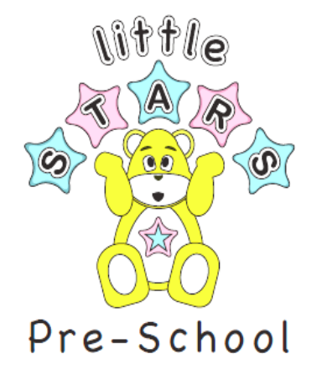

Dear Parents and Carers,

Hope you’re all well,

Look forward to hopefully seeing you all soon if you have not returned to Little Stars this term.

I would like to reassure you that we remain in regular contact with
West Sussex County Council and Public Health England to ensure we have the most up-to-date advice and information.

Please help us to keep you and your children safe

- Please can you wear a mask or face covering when dropping off at Little Stars, Thank you
- Drop off pick up- only one adult on site
- With social distancing in place to minimise contact between the parents, staff, children
- Parents to use back gate at Little stars to limit cross over parents and remove high levels of congestion
- We request that no toys are brought from home or water bottles (unless staying for lunch) as we provide this at little stars
- You must provide a named bag with a clean change of clothes as we do not have any clothes to change your child should they need to be changed.
Please provide nappies and wipes if your child requires them.
- Sun cream- please apply on your child before attending and provide a sun hat with your child’s name on
- Families’ meetings via telephone or email
- “Well child” policy please ensure you adhere- Little stars will contact you immediately if your child has a temperature or becomes unwell

Follow government guidance
It is important that we all take steps to reduce the spread of coronavirus (COVID-19) infection in the community to save lives and protect the NHS. This guidance is for:
- people with symptoms that may be caused by COVID-19, including those who are waiting for a test
- people who have received a positive COVID-19 test result (whether or not they have symptoms)
- people who currently live in the same household as someone with COVID-19 symptoms, or with someone who has tested positive for COVID-19
If you are isolating because of a positive test result but did not have any symptoms, and you develop COVID-19 symptoms within your isolation period, start a new 10-day isolation period by counting 10 full days from the day following your symptom onset.
If you develop COVID-19 symptoms at any point after ending your first period of isolation you and your household should follow the steps in this guidance again.
Symptoms
The most important symptoms of COVID-19 are recent onset of any of the following:
- a new continuous cough
- a high temperature
- a loss of, or change in, your normal sense of taste or smell (anosmia)
If you live in the same household as someone with COVID-19
Stay at home and self-isolate. Do not go to work, school, or public areas and do not use public transport or taxis.

Thank you
Kind Regards Little Stars team

