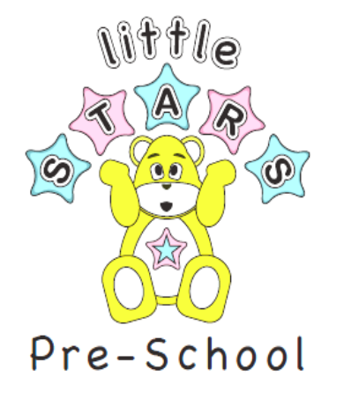
16th October

Dear Parents/Carers

The week commencing 19th- 23rd October

Please join us next week in the Halloween fun!

We are inviting all children to come into Pre-School in their favourite dressing up costume!

Any session that they are in or all week, up to you.

Thank you

Little Stars Team

