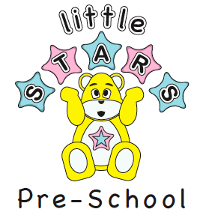

Little Stars Pre School Ltd
At The Mill Primary School
Ifield Drive, Crawley
West Sussex RH11 0EL ©
Telephone: 07975752798
01293 510713
e-mail office@littlestars-preschool.co.uk

24th September 2020

Dear Families,

Healthy lunch

Please can you all provide a Healthy lunch

- No cakes
- No Biscuits
- No sweets

Looking for tips for a healthy Lunch Box, visit the site below

https://www.nhs.uk/change4life/recipes/healthier-lunchboxes

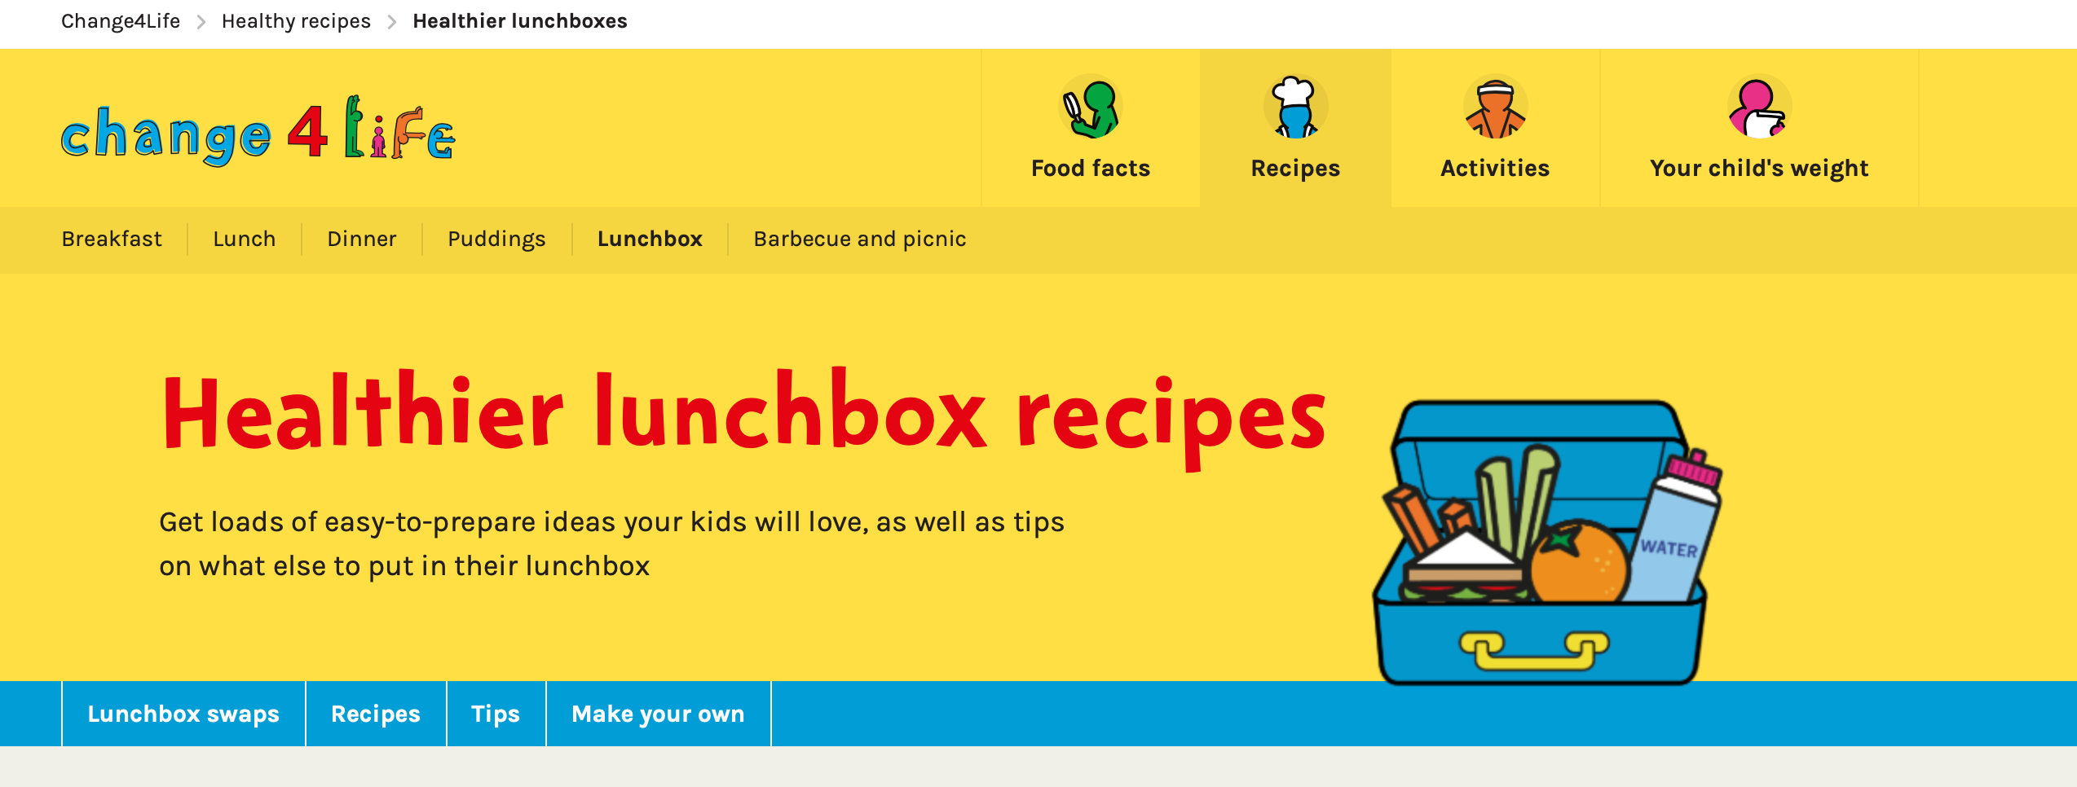

https://www.westsussexwellbeing.org.uk/topics/healthy-eating/what-is-a-healthy-diet

Little stars Nuts free zone at all times

Kindest regards
Little stars Team

